**Login And Register:**

This Screen provides two buttons one is login and another is register, if user has already registered then user can login into application otherwise, user must regiter to go to login

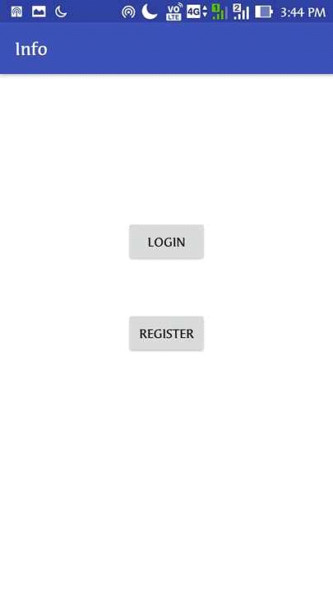

Fig 5.1 login and register

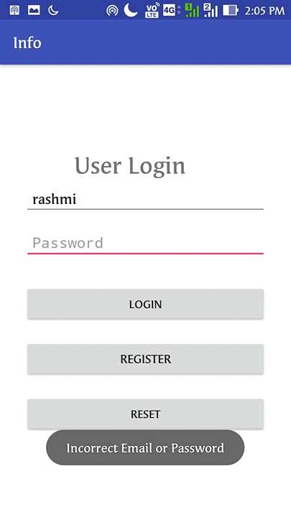

Fig 5.2 login and register

**User Register:**

It provides 6 fields all fields are necessary to fill with an appropriate information of user and then use submit button to save the information of user

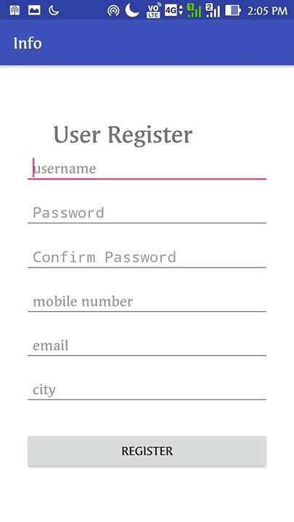

Fig 5.3 user register

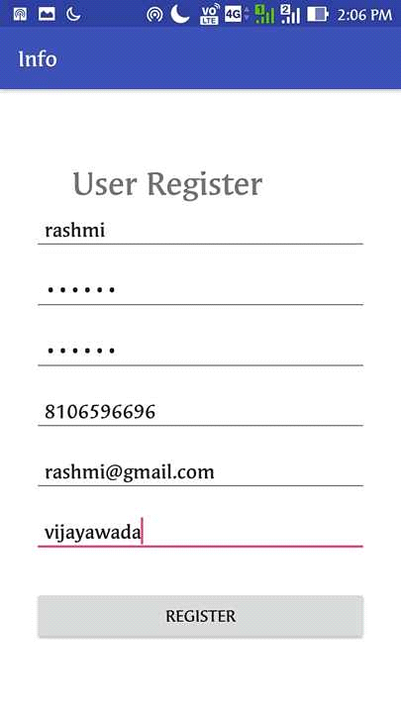

Fig 5.4 User Register

**User Login:**

Login page provides two fields one is username and password and it also provides three buttons one is login, register , reset if user login button in the initial screen without registration then it shows incorrect email or password or else if you entered wrong username and password then also it shows the same message. Username and password are the required fields in login page. If you are not registered there is an option button called register. If you want to reset username and password use reset button.

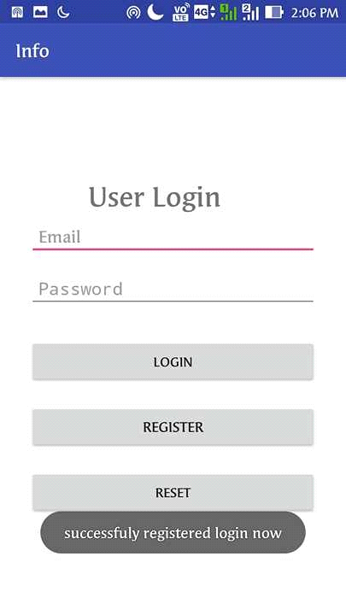

Fig 5.5 User Login

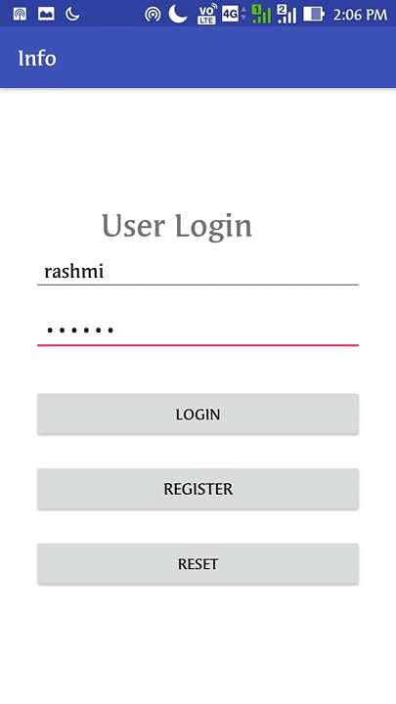

Fig 5.6 User Login

**Welcome User:**

After login the page will navigate to list of depts. User can select the dept as per the user choice. Using fab buttonin dept view list it naviagates into feedback page

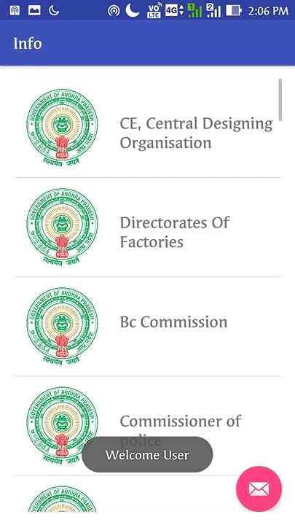

Fig 5.7 Welcome User

**Department Description:**

After selecting the dept page will navigate to dept details it shows image of Dept, Description, Hod name, Address, Landmark, Busnumber from Vijayawada Busstand, and respected dept website url, and Google Map location of respected dept.

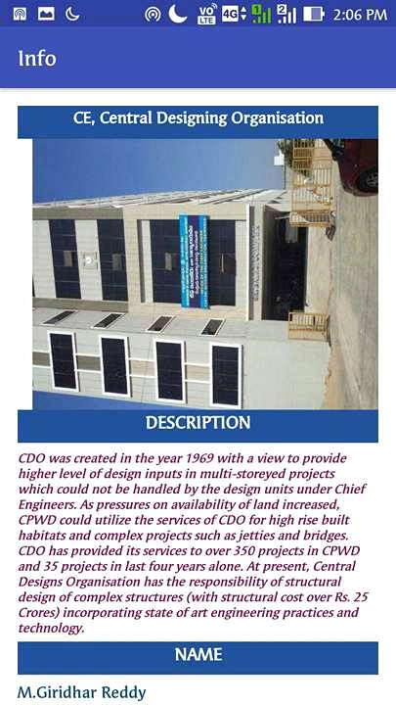

Fig 5.8 Deprtment Description

**FeedBack Form:**

Feedback is the main page for user to depict the problem of user. If user have any problem in application user can communicate with admin by using feedback form. Use submit button after completion of feedback form to communicate with admin. Admin will respond to feedback by providing information.

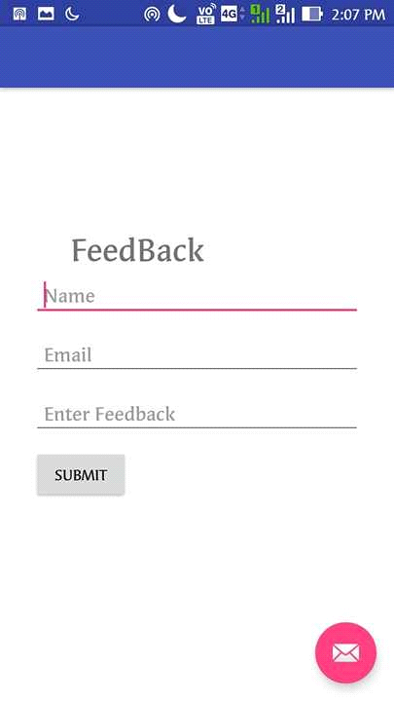

Fig 5.9 FeedBack